**CLARKE AND WRIGHT**

import numpy as np

import operator

from IPython.display import display

import pandas as pd

#Clarke-Wright Savings Algorithm

class CWSA(object):

'''

argument:

create an object with 'distances' attributes.

self.distances[(from_node,to_node)] = distance

output:

'''

def __init__(self):

self.distances = {}

def add_dist(self, from_node,to_node,distance):

if from_node != 'DC' and to_node != 'DC':

if from_node < to_node:

self.distances[(from_node,to_node)] = distance

else:

self.distances[(to_node,from_node)] = distance

elif from_node == 'DC':

self.distances[(to_node,from_node)] = distance

elif to_node == 'DC':

self.distances[(from_node,to_node)] = distance

def CWSA_dist_matrix(cwsa):

'''

argument: cwsa object

output:

CWSA_mtx (numpy array): rows = from_node

columns = to_node

entries = distance (above diagonal element)

diagonal and below diagonal elements are 0

'''

from_list = []

dist_dict = cwsa.distances

for from_node,to_node in dist_dict:

if from_node not in from_list:

from_list.append(from_node)

from_list.sort()

CWSA_mtx = np.zeros((len(from_list),len(from_list)+1))

for from_node,to_node in dist_dict:

if to_node != 'DC':

CWSA_mtx[from_node-1,to_node-1] = dist_dict[(from_node,to_node)]

else:

CWSA_mtx[from_node-1,-1] = dist_dict[(from_node,to_node)]

return CWSA_mtx

def CWSA_savings(cwsa):

'''

Given cwsa object, provide savings and distance table of

argument:

(object): cwsa object with complete distances attribute added by add_dist

function

output:

CWSA_dict(dataframe): 1st column = index

2nd column = (from_node,to_node)

3rd column = distance/cost saving for these nodes

CWSA_mtx (dataframe): distance/cost (above diagonal element) and

saving (below diagonal element) of each pair of nodes

'''

CWSA_mtx = CWSA_dist_matrix(cwsa)

CWSA_dict = {}

for i in range(np.shape(CWSA_mtx)[0]):

for j in range(i+1,np.shape(CWSA_mtx)[0]):

saving = CWSA_mtx[i,-1] + CWSA_mtx[j,-1] - CWSA_mtx[i,j]

CWSA_mtx[j,i] = saving

CWSA_dict[(i+1,j+1)] = saving

CWSA_list = sorted(CWSA_dict.items(),key=operator.itemgetter(1),

reverse=True)

CWSA_savings_df = pd.DataFrame(CWSA_list)

CWSA_df = pd.DataFrame(CWSA_mtx)

return CWSA_df,CWSA_savings_df

from IPython.display import display

cwsa = CWSA()

cwsa.add_dist(1,2,16.3)

cwsa.add_dist(1,3,16.5)

cwsa.add_dist(1,4,20)

cwsa.add_dist(1,5,19.6)

cwsa.add_dist(1,6,17.9)

cwsa.add_dist(1,7,9.3)

cwsa.add_dist(1,'DC',12.7)

cwsa.add_dist(2,3,7.2)

cwsa.add_dist(2,4,14.9)

cwsa.add_dist(2,5,16.6)

cwsa.add_dist(2,6,16.6)

cwsa.add_dist(2,7,12.7)

cwsa.add_dist(2,'DC',11.5)

cwsa.add_dist(3,4,8.9)

cwsa.add_dist(3,5,10.1)

cwsa.add_dist(3,6,11)

cwsa.add_dist(3,7,10.8)

cwsa.add_dist(3,'DC',9.8)

cwsa.add_dist(4,5,7.3)

cwsa.add_dist(4,6,13.4)

cwsa.add_dist(4,7,19.1)

cwsa.add_dist(4,'DC',17.5)

cwsa.add_dist(5,6,12.9)

cwsa.add_dist(5,7,16.4)

cwsa.add_dist(5,'DC',16.1)

cwsa.add_dist(6,7,9.4)

cwsa.add_dist(6,'DC',17.4)

cwsa.add_dist(7,'DC',3.6)

CWSA_df, CWSA_savings_df = CWSA_savings(cwsa)

display(CWSA_df)

display(CWSA_savings_df)

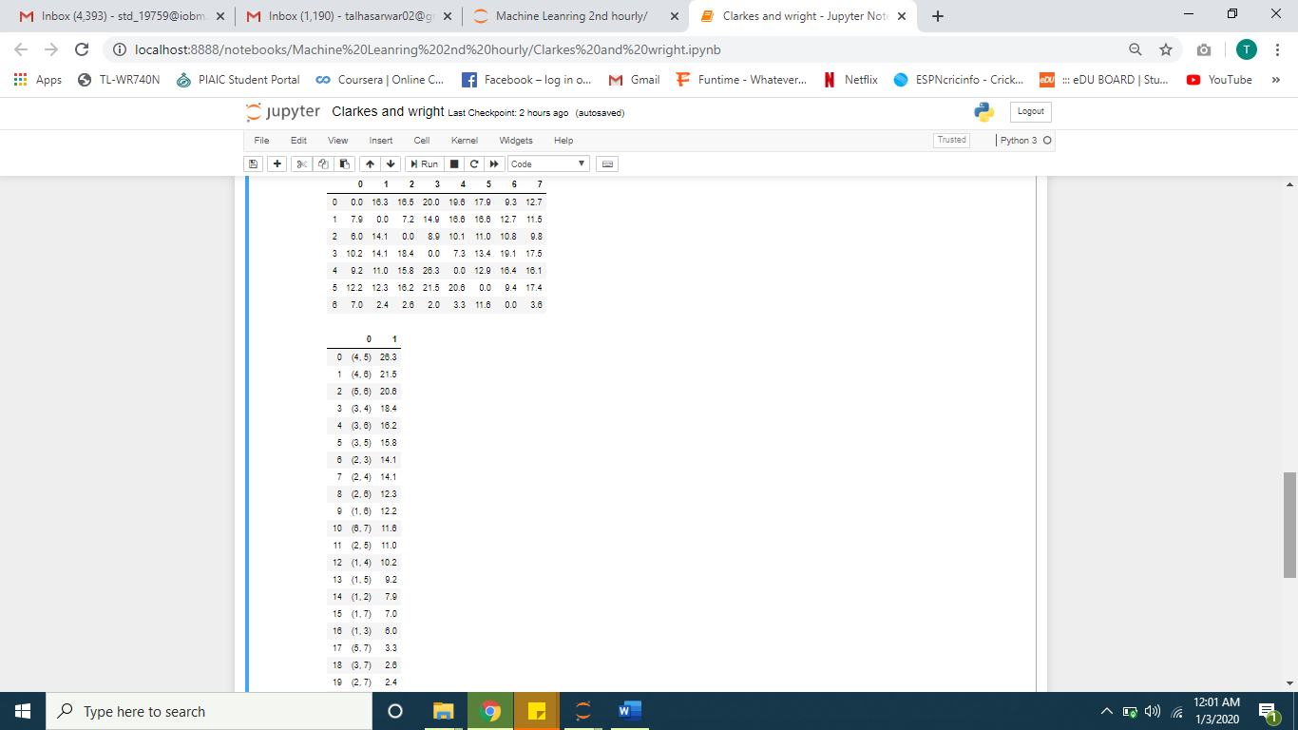

HOLMES AND PARKER print ('Holmes and parker - route with the greatest saving')  
print (' Stop\n',

CWSA_savings_df.loc[0,0], 'Saving: ', CWSA_savings_df.loc[0,1], '\n',

CWSA_savings_df.loc[2,0], 'Saving: ', CWSA_savings_df.loc[0,1]+CWSA_savings_df.loc[2,1],'\n',

'Stop\n',

CWSA_savings_df.loc[6,0], 'Saving: ', CWSA_savings_df.loc[0,1]+CWSA_savings_df.loc[2,1]+CWSA_savings_df.loc[6,1],'\n',

CWSA_savings_df.loc[16,0], 'Saving: ', CWSA_savings_df.loc[0,1]+CWSA_savings_df.loc[2,1]+CWSA_savings_df.loc[6,1]+CWSA_savings_df.loc[16,1],'\n',

CWSA_savings_df.loc[15,0], 'Saving: ', CWSA_savings_df.loc[0,1]+CWSA_savings_df.loc[2,1]+CWSA_savings_df.loc[6,1]+CWSA_savings_df.loc[16,1]+CWSA_savings_df.loc[15,1],'\n',

'Stop\n'

)

